**CCTV pipeline inspection equipment**

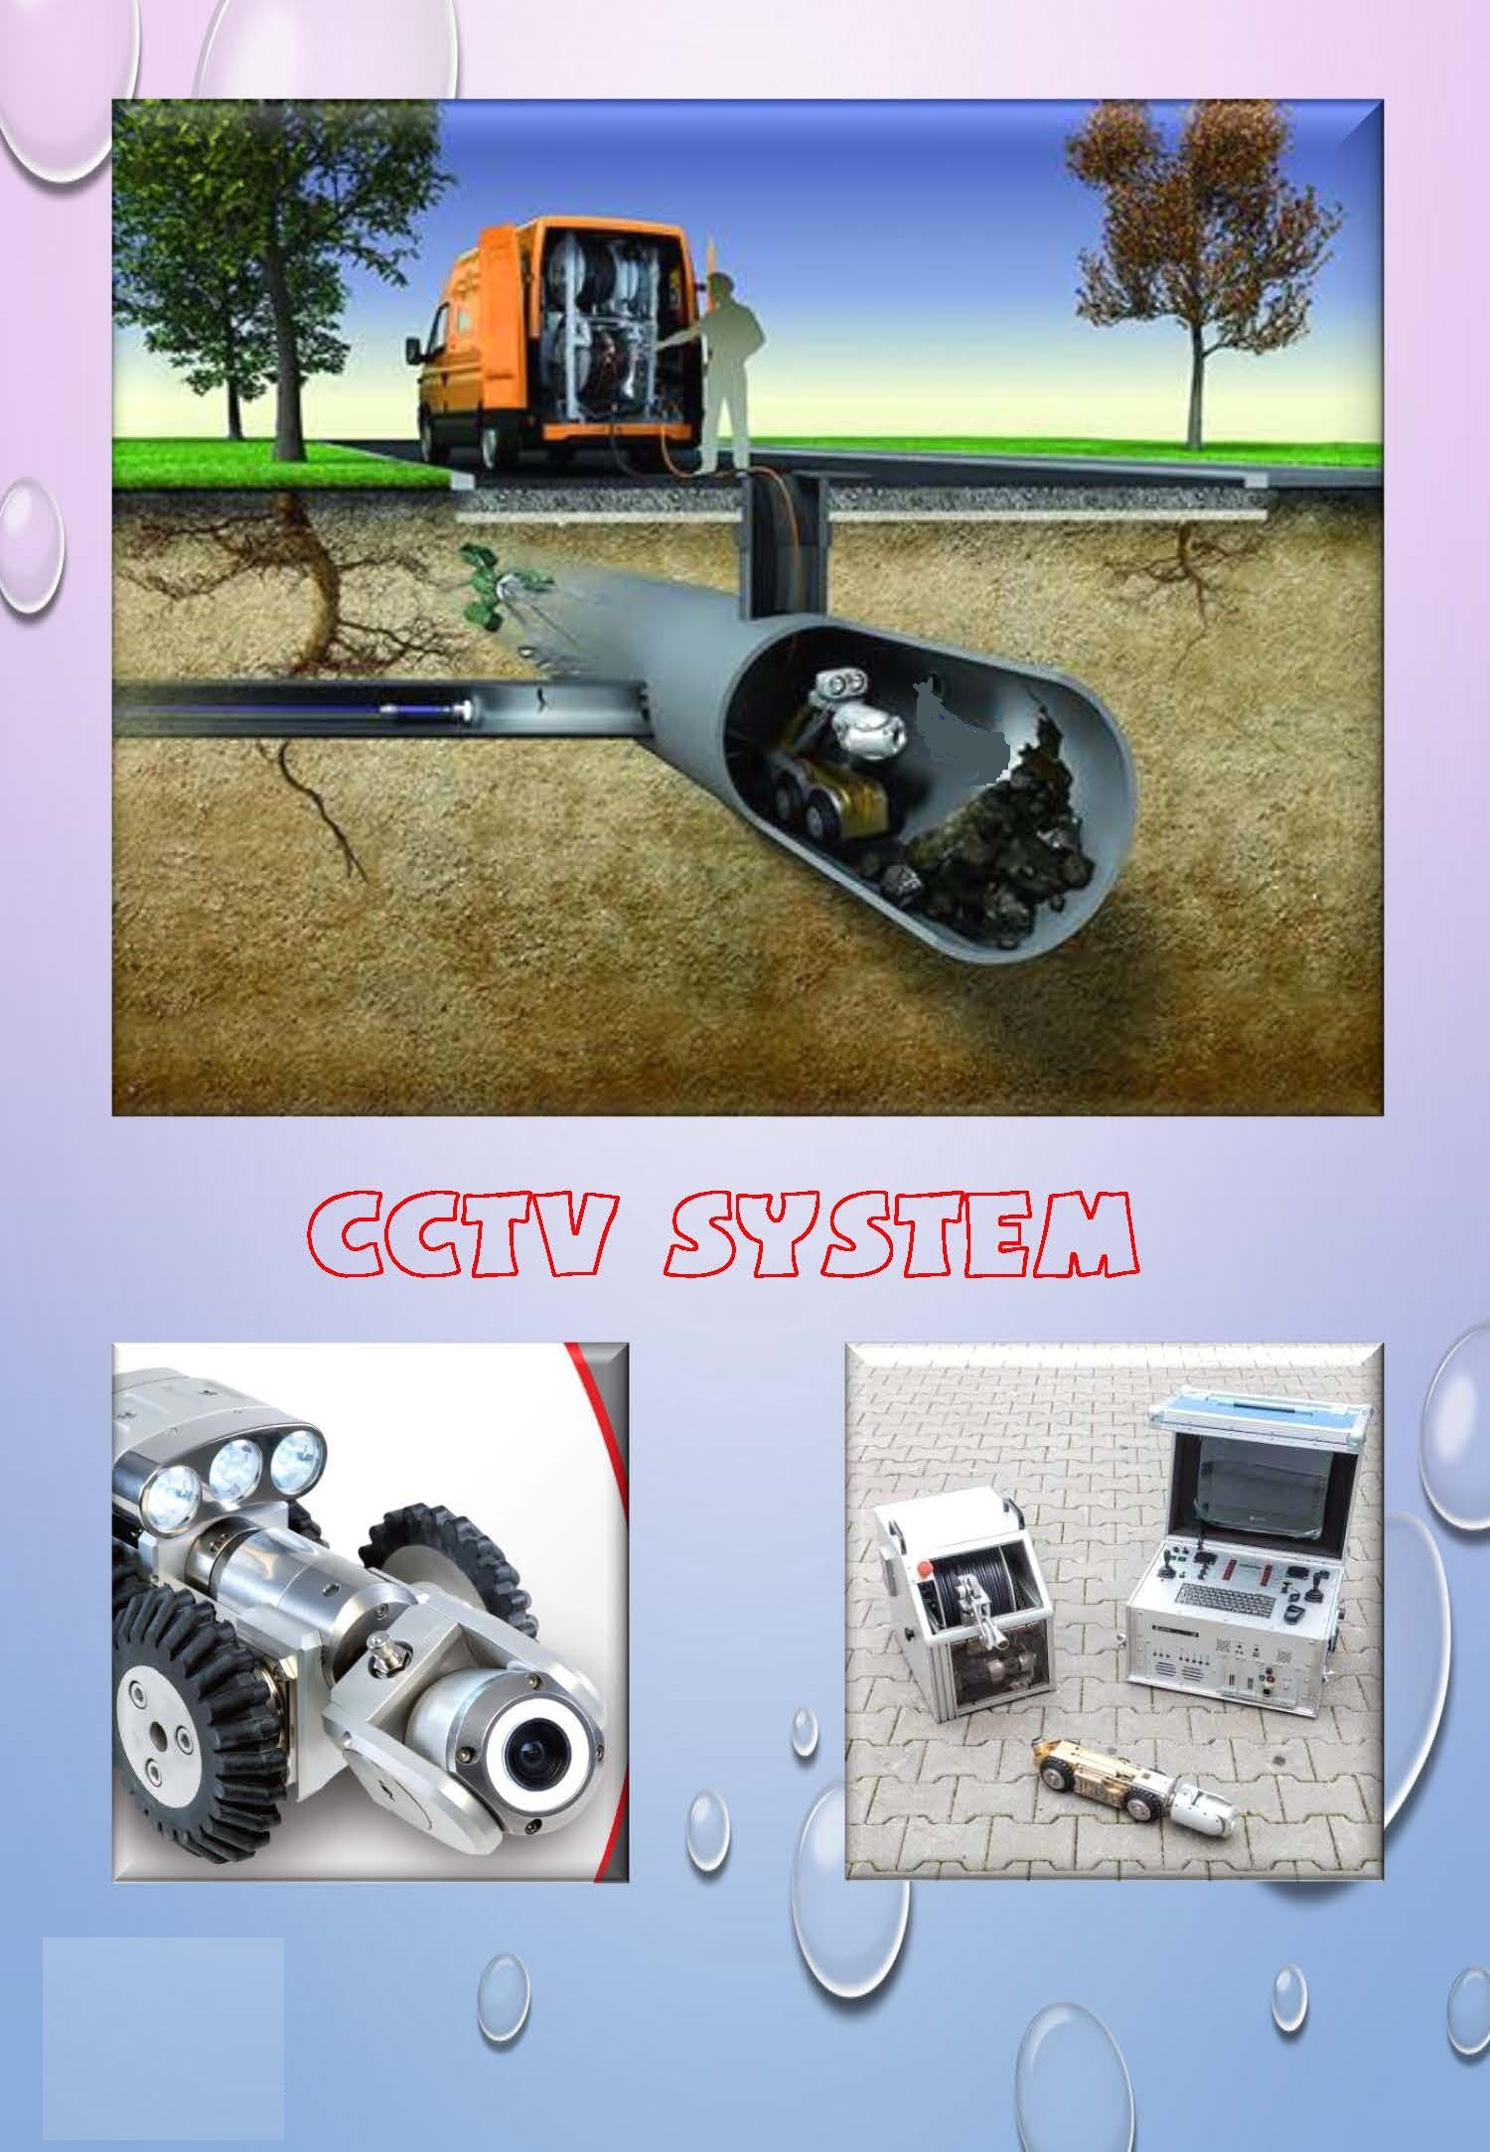

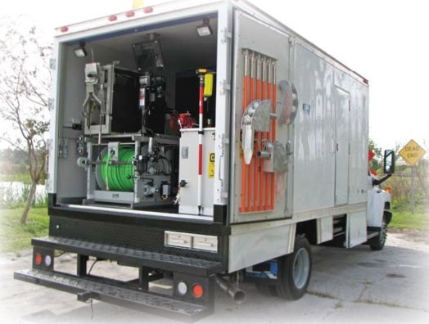

**Trucks, Vans systems**

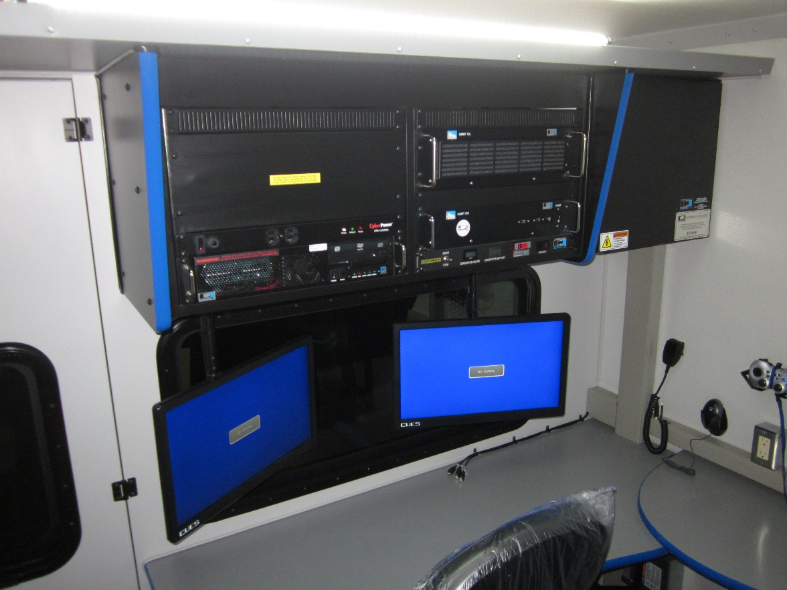

**Camera**

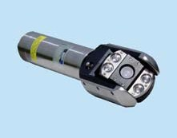

**Mini - cameras**

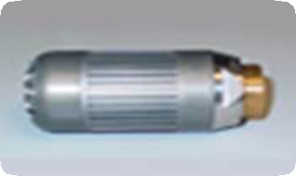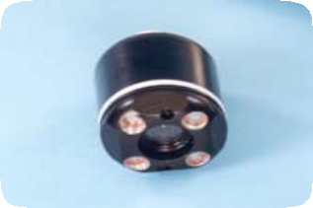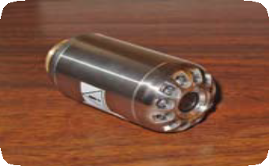

**Pan-and-Tilt TV Inspection Cameras**

Different Inspection cameras incorporate the latest video technology to provide up-close imaging of pipe walls and surfaces during sewer line inspections

Some cameras are designed to pan up to 330 degrees in two direction (165 degrees in each direction) and rotate 360 degrees.

Remote control for iris and focus is provided to assure the highest picture quality in unusual or special conditions

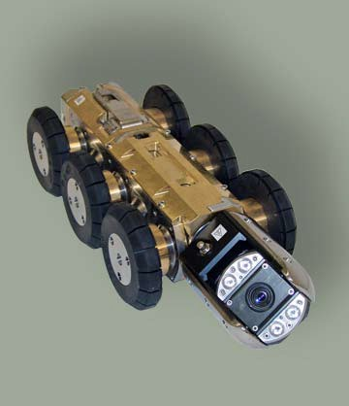

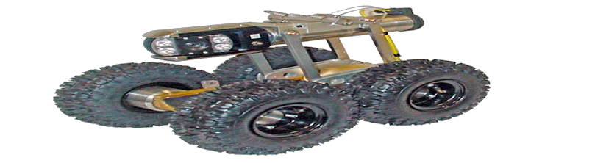**Camera Transporters**

**Steerable Pipe crawler Compact Pipe crawler**

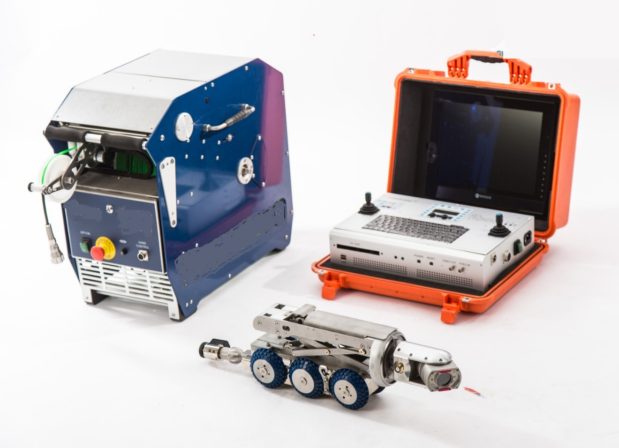

**Various combinations of camera crawlers, cable drums, control units and possible accessories**

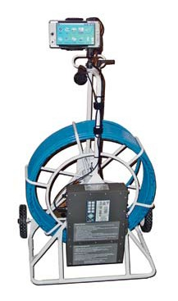

**Portable systems are manufactured for rugged reliability and designed to handle rigorous field use**

While CCTV is the standard acceptable method of visually inspecting pipelines above the waterline, it cannot provide visual information on internal pipe conditions below the waterline.

The Sonar Profiler System provides accurate dimensional data on silt level, grease accumulation, pipe deformation, offsets, etc, below the waterline.

The Laser Profiler is designed to provide the contractor, municipality, or consulting engineer with the ability to determine internal pipeline conditions prior to and/or after rehabilitation

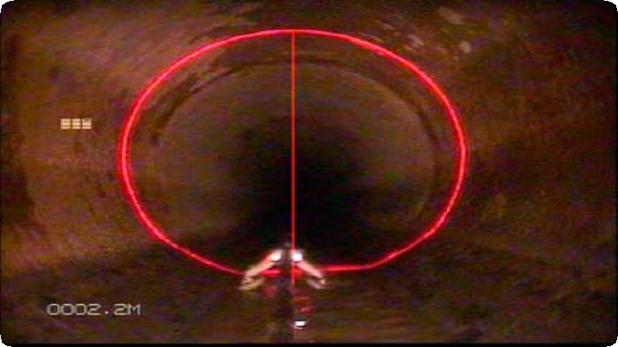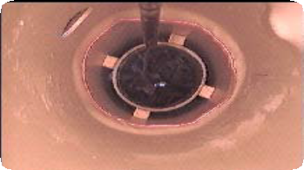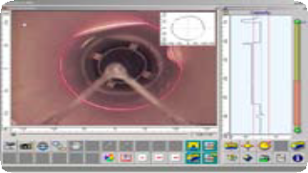

**Laser Profiler**

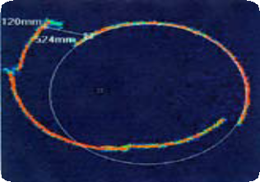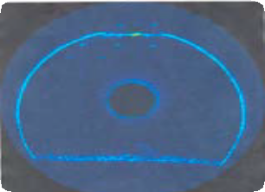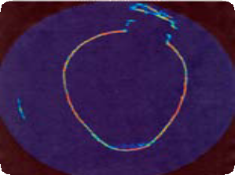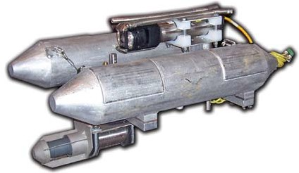

**Sonar Profiler**

40 Inch Siphon

Broken Pipe w/ Circle & Measurement Pipe Image with Lateral Opening

g